**D3 Horse Management Checklist 2023**

Candidates: Each bullet point in ***Section 1*** must be signed off by your instructor.

Topics in ***Section 2*** must be filled out like a study guide and turned in

with Section 1, four weeks prior to test date.

**Section 1:**

|  |  |
| --- | --- |
| Topic | Sign & Date |
| Rider in safe and neat attire, in accordance with the SOP. (Instructor: What are they planning on wearing?) |  |
| Mount to be well brushed (no sweat), clean (no dirt), with feet picked out, showing farrier care. Mane and tail brushed and eyes, nose, lips, and dock wiped off. |  |
| Tack to be safe, especially stitching on stirrups/girth and clean. No jockeys or dust, **stress points clean**, stirrup pads (if used) clean, and bit clean. All tack must be properly adjusted. |  |
| Groom and tack up independently |  |
| Lead safely from both sides at the walk. |  |
| Demonstrate correctly jogging a mount in a bridle and turning your mount in the correct direction, which is away from you. (Whip may be carried and, if necessary, used to move mount forward.) |  |
| Under direct supervision, apply 1 protective boot and 1 bell boot to a mount’s leg and apply 1 polo wrap to a front leg with assistance if needed. |  |
| Provide a hard copy (in a folder/binder or stapled) of mount’s Health and Maintenance Record Book that contains records for at least 3 months prior to the test. In addition to the information from the D-2 record book, records must contain:   * Dated list of routine care (vaccinations, deworming, shoeing, dentistry) * Daily schedule of care which may include grooming, riding, clinics, etc. |  |

**Section 2:**

**Tack:**

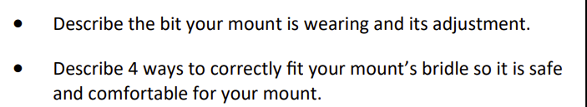

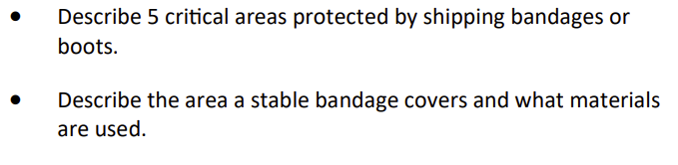**Bandaging:**

**Foot and Shoeing:**

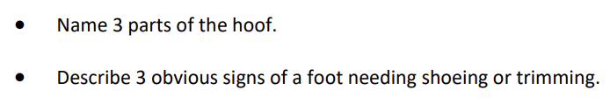

**Breeds, Pony Parts, and Conformation**

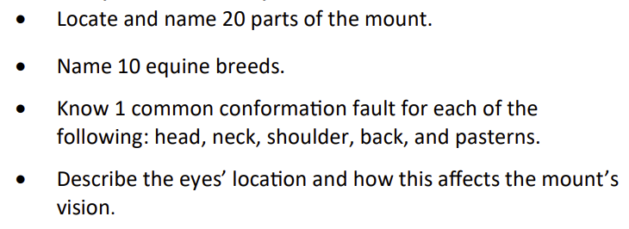

**Stable Management:**

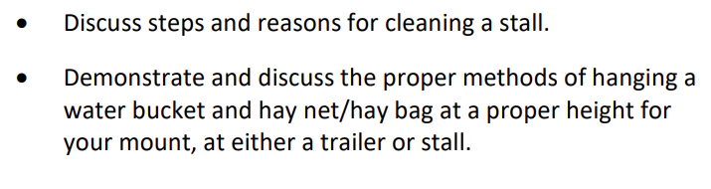

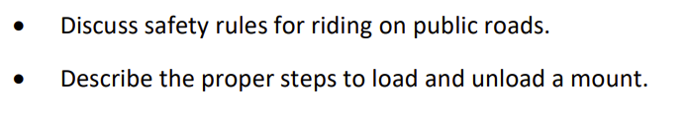**Travel Safety:**

**Land Conservation:**

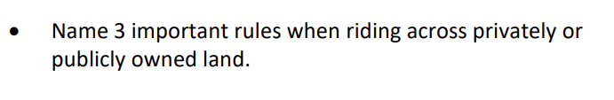

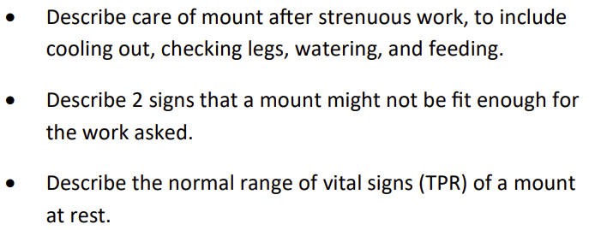**Conditioning:**

**Health Care & Vet Knowledge**

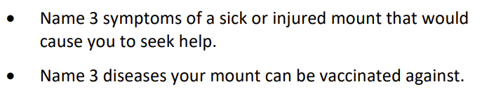

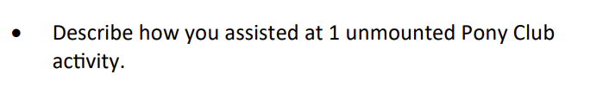**Teaching:**

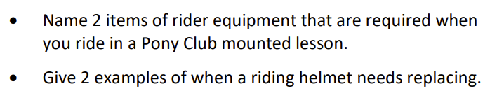**Rider Safety:**

**DC Signature:___________________________________________________________**

**Date Received: __________________________________________________________**